2017 Review Pack
Science
Grade 9

Chapter 1 Review
Matter
Atom: _________________________________________________________________________
Molecule: _____________________________________________________________________

Mixtures
Heterogeneous _________________________________________________________________
Homogeneous_______________________________________________________________
Colloid________________________________________________________________________
Solution_______________________________________________________________________
____________________+ ________________________= solution
Which part of a solution is usually a solid _____________________________
Which part of a solution is usually a liquid ______________________________

Concentration M
C V
What are the Equations for these?
c=

m=

v=

Name the simple Units
c=
m=
v=

750 ml = ________L
2569 ml = __________L
0.035L = _________mL
83L = ______________mL

- 14.2 g of potassium chloride, KCl, dissolved in 450 mL of solution

- 31.5 g of calcium nitrate, Ca(NO₃)₂, give a concentration of 0.175 g/ml. What is the volume in L?

- What is the mass of potassium permanganate, KMnO₄, dissolved in 60 mL of a 0.028 g/ml solution?

Characteristic Physical properties= ________________________________________________
examples of:

Characteristic chemical properties:_________________________________________________
examples of:

Synthesis
A + B AB
Examples: C + O₂ CO₂ 2H₂ + O₂ 2H₂0

Decomposition
AB A + B
Examples: CO₂ C + O₂ 2H₂0 2H₂ + O₂

Chapter 2 Review
What is energy______________________________________________________________________________
Energy transformation: ______________________________________________________________________
Energy transfer: ____________________________________________________________________________
Forms of Energy
1.
2.
3.
4.
Chemical changes and energy required
1.
2.
3.
4.

Chapter 3 Review
What is a fluid____________________________________________________________________
Compressible fluid_________________________________________________________________
What fluid state is compressible?__________________________________________________________
Why is it compressible?_____________________________________________________________
Draw the particles of a compressible fluid before and after pressure is applied

How pressure exerted by compressible fluid= __________________________________________________
How can pressure change?
1.
2.
3.
One system of the human body that deals with compressible fluids____________________________
Incompressible fluid_________________________________________________________________
What fluid state is incompressible?__________________________________________________________
Why is it incompressible?_____________________________________________________________
Draw the particles of a incompressible fluid before and after pressure is applied

How pressure exerted by incompressible fluid
1.
2.
One system of the human body that deals with incompressible fluids____________________________

Pressure ______________________________________________________________________________
force __________________________________________________________________________________
surface area ______________________________________________________________________________

Result to pressure
Force increases
Force decreases
Surface area increases
Surface area decreases

Which box applies more pressure to the floor that it is on, and why?
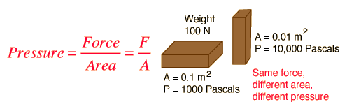

Explain why the truck will cause more road damage than the car

How are their designs different enough to compensate for the road damage?

Chapter 4 Review
What is a wave____________________________________________________________________
waves based on how they propagate
1.
2.
Label the parts:
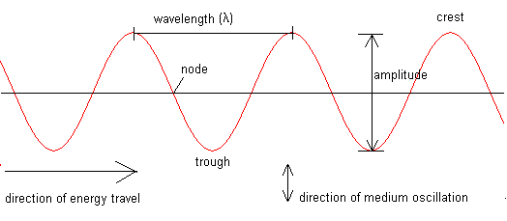

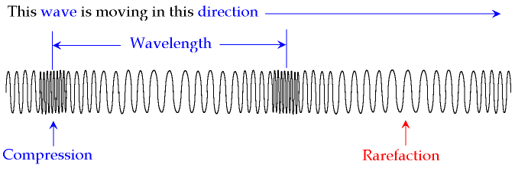

Amplitude: _______________________________________________________________________________
where in transverse wave=__________________________________________________
where in longitudinal wave= _______________________________________________
unit of measure _______________________________________________
corresponds to ______________________________ in sound

wavelength : ______________________________________________________________________________
where in transverse wave=__________________________________________________
where in longitudinal wave= _______________________________________________
unit of measure _______________________________________________

frequency: ____________________________________________________________________________
unit of measure _______________________________________________
corresponds to ______________________________ in sound

types of waves
1.
2.
Difference between the two types of waves?

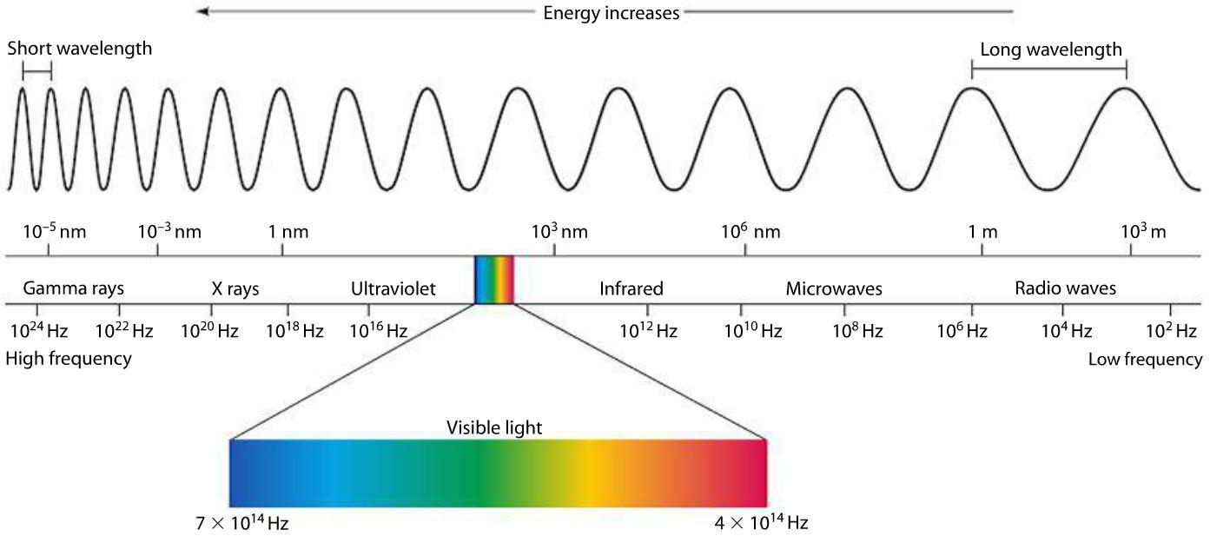
Sound:
explain why there is no sound in space

Explain what happens when a person sings, and then you hear it
person singing:

you hearing:

Lens:
Converging lens do what to light: _____________________________________________________
Shape of lens___________________________________________________
Image produced ___________________________________________________________________________
Used to correct (eye sight problem) ____________________________________________________________
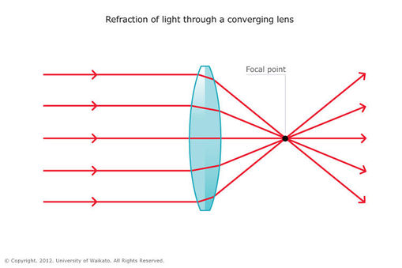
Draw in the light path

Diverging lens do what to light: _____________________________________________________
Shape of lens___________________________________________________
Image produced ___________________________________________________________________________
Used to correct (eye sight problem) ____________________________________________________________
Symbol
draw the light path
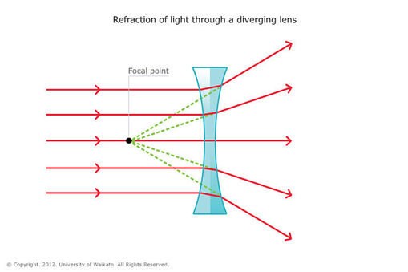

Chapter 5 review

Why do cells divide? _____________________________________________________________________
How many chromosome do humans have?_______________ how many pairs?__________________
The 23rd pair is the sex chromosome. What is male?______________ what is female?_______________

What is mitosis? ____________________________________________________________________
How many daughter cells produced? ___________________________________________________
# Chromosomes in parent cell? ____________ # chromosomes in each daughter cell________________

What is mieosis?____________________________________________________________________
How many daughter cells produced? ___________________________________________________
# Chromosomes in parent cell? ____________ # chromosomes in each daughter cell________________

What is a tissue?________________________________________________________________________
Examples of tissues _____________________________________________________________________
What is an organ?______________________________________________________________________
Examples of organs _____________________________________________________________________
What is a system? _______________________________________________________________________
Examples of systems ______________________________________________________________________
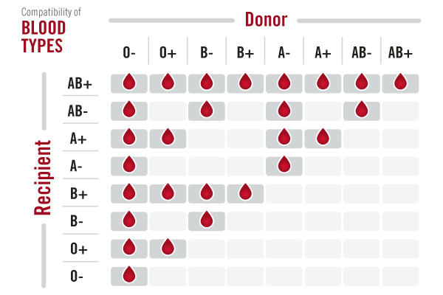

Hormones in Males and Females
 | Name | Function
Women
Hormones that trigger puberty

Sex hormones

Men
Hormones that trigger puberty

Sex hormones

Oogenesis is _____________________________________________________________________________
Oogenesis creates _______________________
Spermatogenesis is ________________________________________________________________________
Spermatogenesis creates __________________

Chapter 6 review
Nutrition
Nutrient | Description | function | Food source

What happens to the body if kj/ calorie intake is higher than kj/calorie expenditure? _____________________
What happens to the body if kj/ calorie intake is same as kj/calorie expenditure? ________________________
What happens to the body if kj/ calorie intake is lower than kj/calorie expenditure? _____________________
What type of food(s) would be best…
- Before physical activity ________________________________________________________________
- To give you a quick boost of energy _____________________________________________________
- If you are thirsty _____________________________________________________________________

Canada’s food guide
Food group | # servings for YOU | Food example

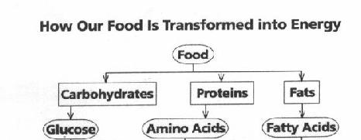

Digestive system
Functions of the digestive system:
1.
2.
4 steps of digestion and what happens at each step:
1.
2.
3.
4.

What is the muscle movement called that moves food from the mouth to the stomach? ______________________
What is the fancy word for swallowing?_______________________________________________________________
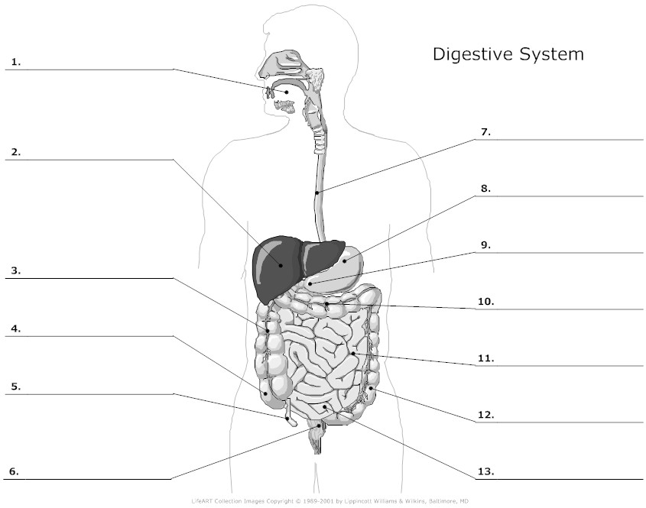

What is mechanical transformation?____________________________________________________________________
__________________________________________________________________________________________________

Type of mechanical transformation | where | What happens

What is chemical transformation?______________________________________________________________________
__________________________________________________________________________________________________

Digestive gland | Secretes (makes) | Where? | Targets which nutrient?

If you ate a 100% beef hamburger on a bun with cheese, bacon and tomato, where would it all get digested mechanically and chemically?
Mouth-
Stomach-
Small intestines-
Large intestines-

Respiration
Why do we need respiration?__________________________________________________________________________
Air is a _____________________________________ fluid which means ______________________________________
_________________________________________________________________________________________________
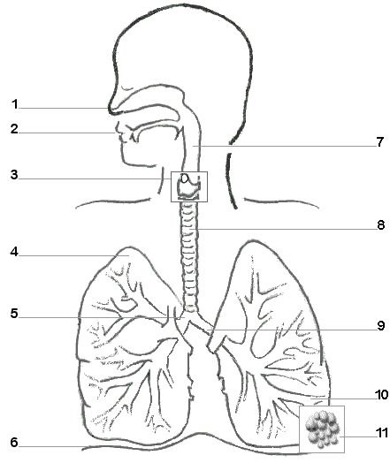

Structure | Where? | function
bronchiole
alveoli

Where does the gas exchange happen in the lungs?______________________________________________ Which gas is inhaled to be used by the body?_____________________________________________________
Which gas is exhaled by the body?______________________________________________________________
Where is the concentration of oxygen (O₂) highest on an inhale? ______________________lowest ? _______________
Where is the concentration of carbon dioxide (CO₂) highest on an inhale? _______________lowest ? _______________

Blood and Circulation
% of blood plasma __________________________ % formed elements ______________________________
Blood component | describe | function

Cardiovascular system
Blood vessel | description | What carries? | direction
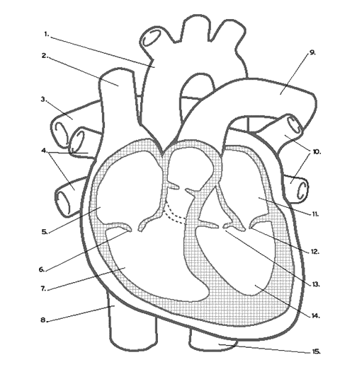

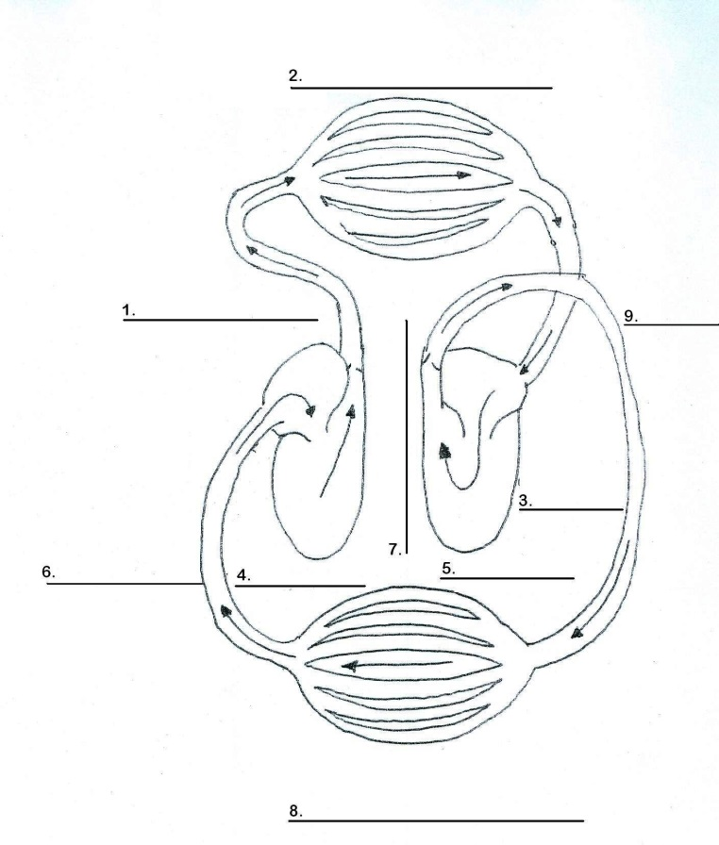
Circulation routes
Fill and colour in the “artist rendition” of the different circulatory routes that the blood takes. red= oxygenated blood, blue= deoxygenated blood.

Function of the lymphatic system: ______________________________________________________________
__________________________________________________________________________________________
Function of the excretory system: ______________________________________________________________
__________________________________________________________________________________________

Chapter 7 review
Order that the nervous system deals with stimuli
1.
2.
3.
4.
Name of the nerve cell______________________________________
What is a nerve impulse? _________________________________________
What is a synapse? ___________________________________________
What are sensory receptors? ____________________________________________________________________
What are sensory nerves?________________________________________________________________________
What are motor nerves?__________________________________________________________________________
5 functions of the cerebrum
1.
2.
3.
4.
5.
What does the cerebellum do?_________________________________________________________________________
What does the brain stem do? _________________________________________________________________________
What does the spinal cord do? _________________________________________________________________________
Describe a reflex arc/path ____________________________________________________________________________
_________________________________________________________________________________________________

Structure of eye | describe
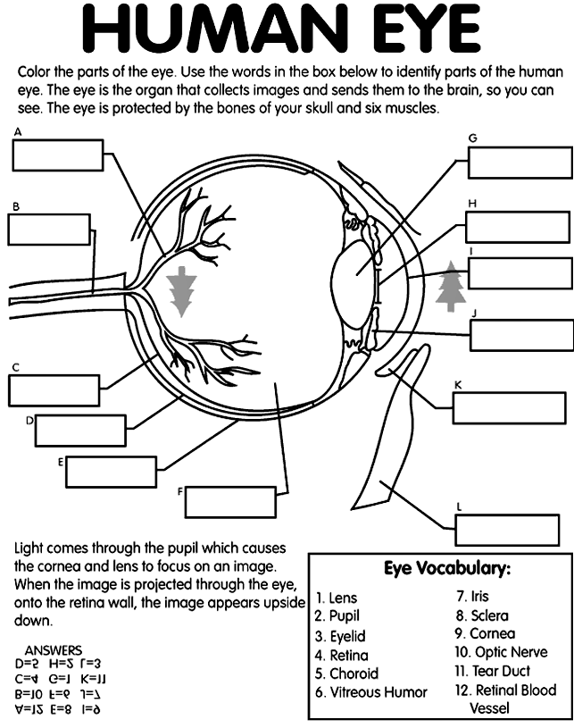

What is Myopia (nearsightedness)? _______________________ ____________________________________________________
What lens corrects it? __________________________________
What is Hyperopia (farsightedness)? ______________________ ____________________________________________________
What lens corrects it? ________________________________

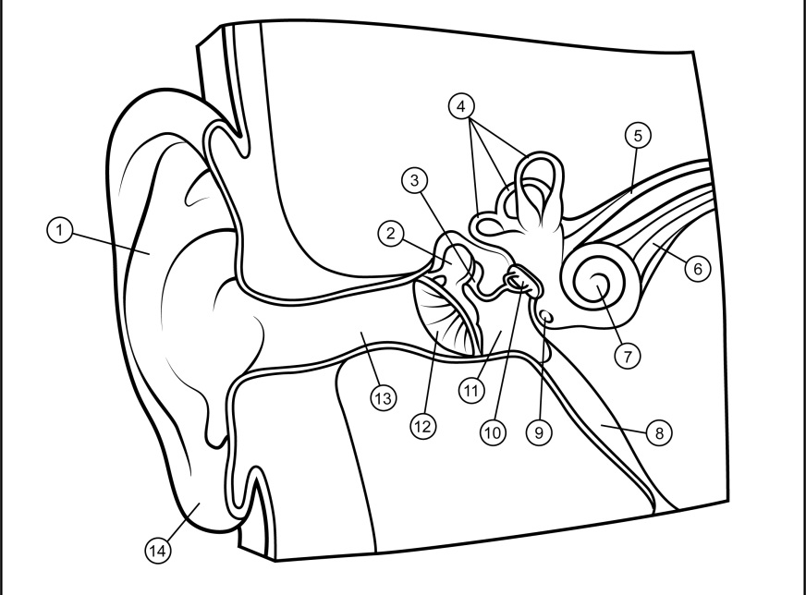
What is sound? ___________________________________________
Other than hearing, what else does the ear do? ___________________________________________

 | structure | describe
Outer ear
Middle ear
Inner ear

What is a bone?_____________________________________________________________________________________
5 functions of bones
1.
2.
3.
4.
5.
Type of muscle | describe | where

Functions of joints
Name the movements of the following joints.
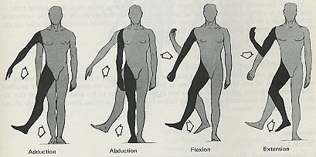

Biotechnology – Pasteurization
Pasteurization is: _______________________________________________________________
Main reasons for pasteurization
1.
2.
3.
Benefits:
Concerns:

Earth – Favourable conditions for the emergence of life
The conditions essential for the emergence of life on earth are: _________________________
_____________________________________________________________________________

Condition | Details

Geological time scale
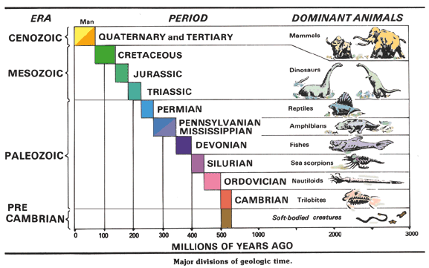

Technology review

What is technology? _____________________________________________________________________
Identify the following lines:

25

Label the isometric projection
Label the top, side and front views
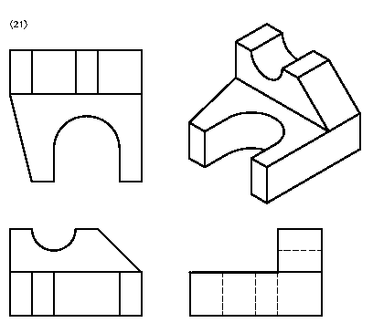

Draw a roational force arrow
draw a translational force arrow
Draw a rotational motion arrow

draw a bi-directional translation motion arrow
What is raw material?_______________________________________________________________________
What is material? ________________________________________________________________________
What is equipment? _______________________________________________________________________

What is a mechanical property? ________________________________________________________________
6 kinds of mechanical properties of materials
1.
2.
3.
4.
5.
6.
Why is wood used to build things? _____________________________________________________________
__________________________________________________________________________________________
What is a metal? __________________________________________________________________________
What is an alloy? _________________________________________________________________________

What are components? ____________________________________________________________________
What is a basic mechanical function? _________________________________________________________
What is guiding? __________________________________________________________________________
What are the two kinds of guiding?
1.
2.

Complex mechanical functions
what is a system? _____________________________________________________________
what is the driver? ___________________________________________________________
what is the driven?___________________________________________________________________
what is an intermediate component?______________________________________________________
What is motion transmission? _____________________________________________________________

Motion Transmission system | advantage | disadvantage

How can you get a speed change in a wheel or pulley system?________________________________________
How would you slow down a system? ___________________________________________________________
How would you speed up a system? ____________________________________________________________
How can you get a speed change in a gear system?________________________________________________
How would slow down a system? ______________________________________________________________
How would you speed up a system? ____________________________________________________________
What is motion transformation? _______________________________________________________________
Motion Transformation system | Advantage | Disadvantage

Transmission of motion
Example: Gear train
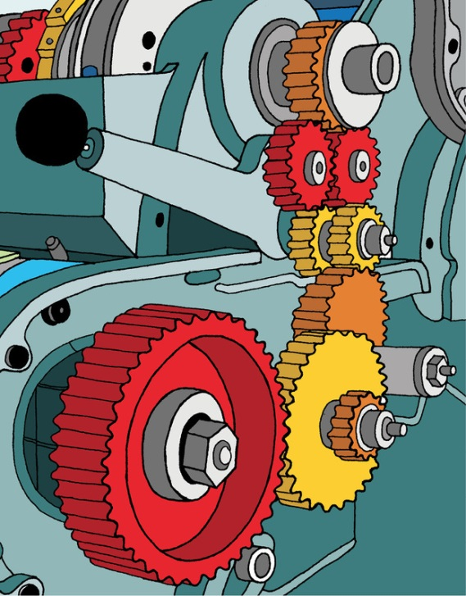

Transformation of motion
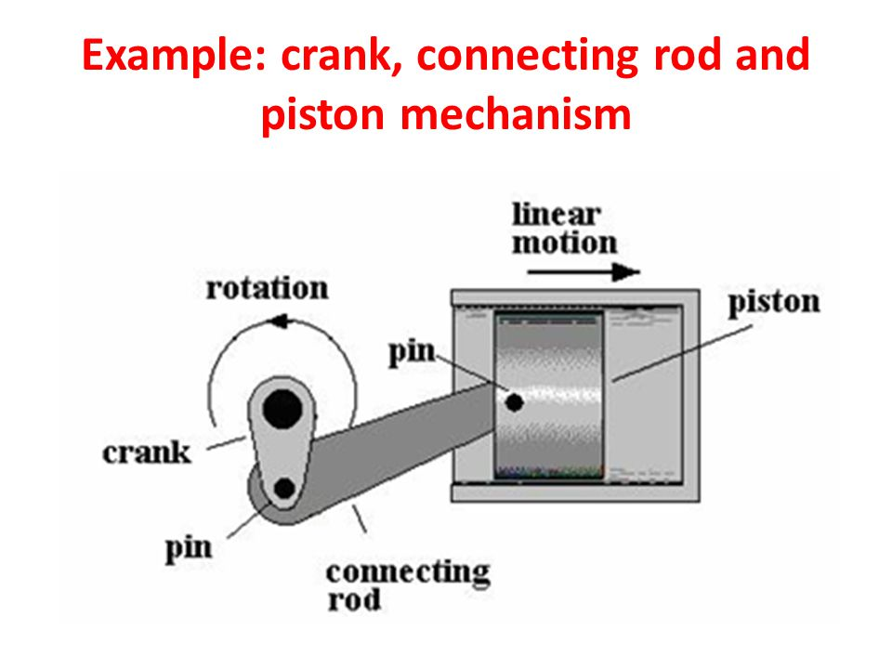

Concentration Exercises
1. What is the concentration of a 365 ml solution containing 19 g of solute?

2. If 55 g of magnesium chloride is dissolved in 197 ml of alcohol, what is the concentration in g/L?

4. What mass of solute is needed to prepare a 250 ml of a 35 g/L solution?

5. How many ml of solution is needed to dissolve 33 g of solute if the concentration of the solution is 52 g/L?

6. A student is told to prepare 100 ml of a 77 g/L solution. How much mass will she need?

7. 22 g of NaCl dissolves in 60 ml of water at 22 degrees Celsius. What is the
solubility of the salt?

